## Field settings

Under “Tools > Configuration > Field Settings” you’ll find the tools to adjust and fine-tune on field label basis. For every I/O you attach a label onto you will find different ways of tuning in each tab of field settings.

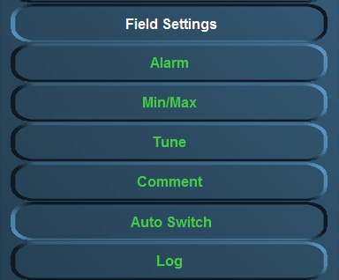

Figure 11‑4: Field settings

The following settings are available:

* **Alarm**  
  Settings of user alarms, warning alarms, critical alarms, Alarm group settings, SMS settings, inhibit settings
* **Min/Max**  
  Setting of instrument range, zone marking, default unit and filter
* **Tune**  
  Setting of tuning table, see results and sender
* **Comment**  
  Check and change group label, group label logbook, field label and field label instrument
* **Auto Switch**

Make various in-and outputs react on each other.

* **Log**  
  Setting and enabling/disabling logging for each field label.

### Alarm

Choose the field you would like to change the alarm settings for (e.g. “Steering and Propulsion >Rudder > Angle”).   
Depending on the field selection, a number of field settings are available. In this example the following settings are allowed:

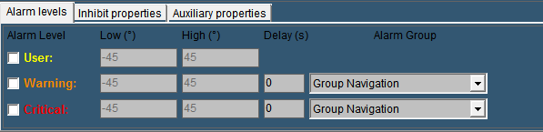

Figure 11‑5: Alarm settings

An alarm field as this “rudder alarm” is not set as alarm by default. It gives an analogue value )in this case within the range -45 degree and +45 degree. Now within this range you can set a few alarms. The settings that can be altered are the following:

#### Alarm levels

* + **User**Via this check box the user alarm settings are set. In this example you can set the alarm threshold (low and high). Usually you will not set them here but in the instrument itself (it is a user alarm) but you can check and/or change them here
  + **Warning**   
    The warning alarm is a dedicated alarm to warn the user when certain thresholds are exceeded. This alarm can have a dedicated delay and a dedicated alarm group (i.e a high or low alarm).   
    Choose these thresholds widely within the boundaries of the capabilities of the attached device (check specific manual for the values)
  + **Critical**To set the critical alarm thresholds (i.e. too high or too low) (check specific manual for these values).
* **Delay(s)**The time (in seconds) the system will wait before it will show the specific alarm that is triggered. This is necessary if a hysteresis is needed (i.e. a bilge alarm that is on the edge of the alarm by the rocking of the ship, will not go of all the time if you put in a delay)
* **Alarm Group**Here you can put the alarm in a specific group. By putting it in a group you can manage the rights of different users on whether they can silence or acknowledge these alarms. For more detailed information please refer to chapter “Alarm stations”.

By example it will look like this (see Figure 11‑6).

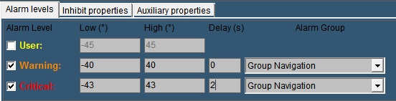

Figure 11‑6: Alarm example

The next tab is for the inhibit properties.

#### Inhibit Properties

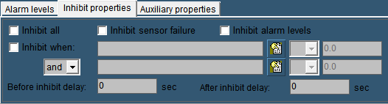

Figure 11‑7: Inhibit Properties

There will be certain occasions where you do not want the alarm to go off. For example an oil pressure alarm from an engine will normally also be in alarm when the engine is shut down. This is not wanted as an alarm. Or when a sensor is broken and there is no time to repair it for a while, it will be easier to inhibit the “Defect Alarm” of this sensor until you have time to repair it.

* **Inhibit All:**

This checkbox is used to inhibit all the alarms from this particular sensor. Especially when the sensor is defect, it will come in handy. In the alarmpage (See Alarmpage) you will constantly see that the sensor is inhibited, so you won’t forget.

* **Inhibit Sensor Failure**Some sensors (i.e. 4-20 mA) tends to go a little bit out of range. Normally this will be no problem. However if a 4-20 mA sensor drops below 4 mA or goes higher than 20 mA, FT NavVision® will see this as a sensor failure and will give an alarm. If you think it is just the range of the sensor that is giving the problem, you can check this box to stop these alarms.
* **Inhibit Alarm Levels**If you have set alarm levels as mentioned in “Alarm Levels” And you need them out for a while, check this box.
* **Inhibit When**

In the earlier mentioned oil pressure alarm, you don’t want that alarm to go off when the engine is not running. This is where “Inhibit When” will help. In the inhibit properties of that particular sensor you mark the checkbox. Now you search the belonging engine running field in the box next to that, by clicking the tab besides that. While you want the alarm to be inhibited when the engine is not running, in the next field you choose “<” from the dropdown menu. Finally you set an amount (in this case 0.5) in the adjacent field. Now, when the engine is not running, the alarm will not sound. (see Figure 11‑8). Finally you can choose an additional field (And/Or) to specify even further. For example you can use the Shaft Speed RPM as backup. (see Figure 11‑9).

“Before Inhibit Delay” and “After Inhibit Delay” are delays to catch up for irregularities in the sensors behavior.

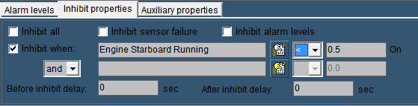

Figure 11‑8: Inhibit When

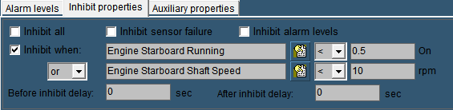

Figure 11‑9: Inhibit When 2

 *If you specify just one inhibit field, make sure the “and/or” box is set to “and”. Otherwise the alarm field will not work.*

#### Auxiliary Properties

* **Alarm Sound:**

Obsolete

* **Send SMS When Alarm Active**If you have the SMS Alert License you can tick this checkbox to send a text message to your phone, every time the alarm is triggered.
* **Alarm On Request Timeout**Especially valves will have a long time to open or close. You can set a timeout on the time to get an alarm if the conditions aren’t met in the given time.
* **Alarm When Not Ready**

If the sensor is equipped whit an output to state that it is not ready, tick this checkbox to get an alarm.